**Route Planning and Delivery Management System**

**Content:**

1. Add CDE Details
2. Add Vehicle Driver Details
3. Add Delivery Van details
4. Route Planning – Map Based
5. Van wise invoice printing
6. Print Delivery Sheet Van wise/bulk
7. Van wise collection settlement and raise exception report.
8. CDE and DC performance

**Purpose:**

* The purpose of this is to ensure that there is clear control on the human resources used in every van delivery.
* These details should be used for CDE performance and report can be generated based on the orders assigned to him for delivery.
* Link the customer feedback for the orders which are delivered by him.
* Area Managers to ensure these details and to correct every time.
* Any new CDE joins, the details to be captured.
* Map based route planning helps Area manager to assign orders to a van quickly and accurate and faster delivery.
* This details can be accessed by trust center for any order follow ups. They can directly contact the CDE and get the delivery status.

1. **Add CDE Details**

**CDE (Customer Delight Executive)-Delivery Person**

Name, Contact Number, Hub, Photo, Employee ID, Designation, Shift, Emergency Contact Number and Address.

This is one time activity and the details should be updated correctly based on the joining reports. AMs should get the details from HR to enter the correct details of the CDE as this serves as daily attendance and includes in the CDE performance parameters.

**Add CDE Details**

|  |  |
| --- | --- |
| First Name |  |
| Last Name |  |
| Mob No |  |
| Address |  |
| Mswape Sl No |  |
| GPS Track SL No |  |
| CDE Photo Upload |  |
| Date of Joining |  |
| Employed by | Dropdown option - Onrole/3PL (If 3PL - Name of the 3PL provider) |
| Employee No |  |
| Employment Status | Dropdown Option - Active/Resigned (Date of resigned when choosing resigned) |
| Shift Type | Dropdown Option - 1st Shift/2nd Shift/Trainee |
| Emergency Contact Number and Address | For emergency purpose to contact their parents or other care takers |

**2. Add Vehicle Driver Details**

Name, Contact Number, Driving License Number, Photo, DL image.

**3. Delivery Vans, GPS Tracker and Delivery Phone Device ID**

* + Delivery van RTO registered number.
  + Delivery phone device ID – to download the orders to the delivery phone which are assigned to this van for order acknowledgement.
  + City, vehicle type (Delivery van/Inter DC van) and DC location.
  + Enable Geofencing – The order locations will be linked to the GPS Tracker map. This will help us to track the entry and exit time of the delivery location. Phase -2
  + GPS tracking Device ID (Serial Number) and Mswpe - the CDE should carry the same device for his van daily.

|  |  |
| --- | --- |
| Add Van |  |
| Vehicle Make | Tata Ace/Mahindra/Ashok Layland |
| Vehicle Reg No |  |
| Vehicle Type | Two Wheeler/Four Wheeler |
| Crate Capacity |  |
| Vehicle Provider | Own/3rd Party (If 3rd Party - Add 3PL Name) |
| GPS Tracking ID |  |
| Upload Documents | RC Book (Upload option) and Date of Expairy (A popup or cannot assign a van during the route plan) |
|  | Insurance |
|  | Fitness Certificate |
|  | Emission Certificate |
| DC Name | Dropdown option for selecting the DC name) |
| Status | Active/Removed |

**4. Route Planning.**

**A. Route Planning for Slot-1**

Option - Select DC Name>Date>slot

All orders should be shown on the map with location icon for the selected slot. H Indication is DC location.

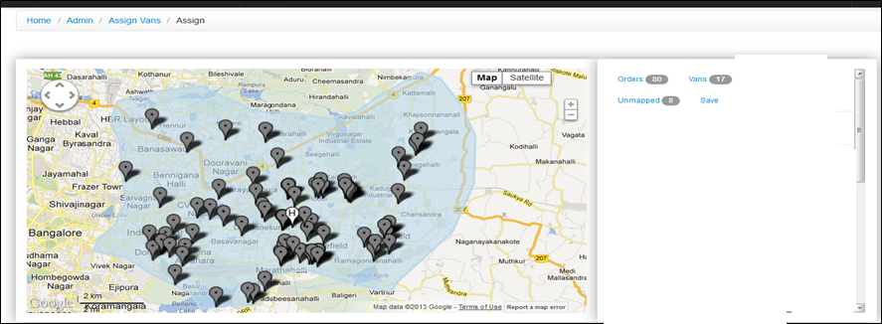

Option to click on order location icon and assign a van it.

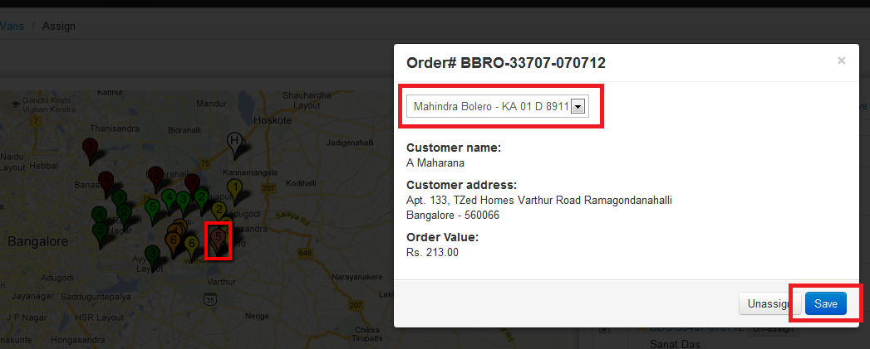

The assigned van to have color for that van.

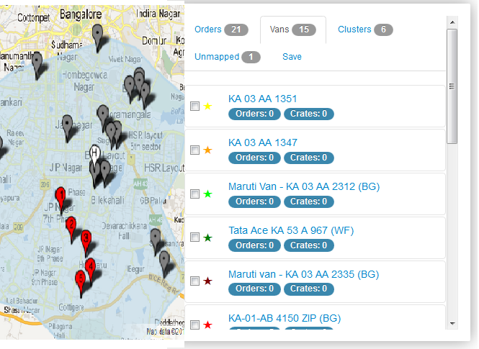

Once all the orders are assigned, option for sequencing. And Assign CDE name option

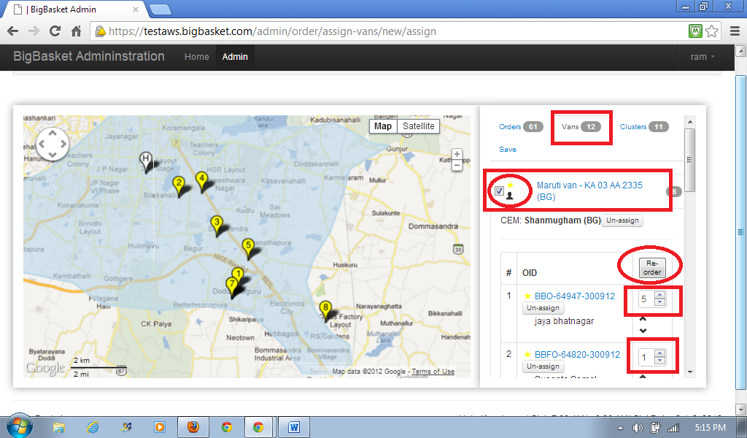

The sequence will be shown after the re-order

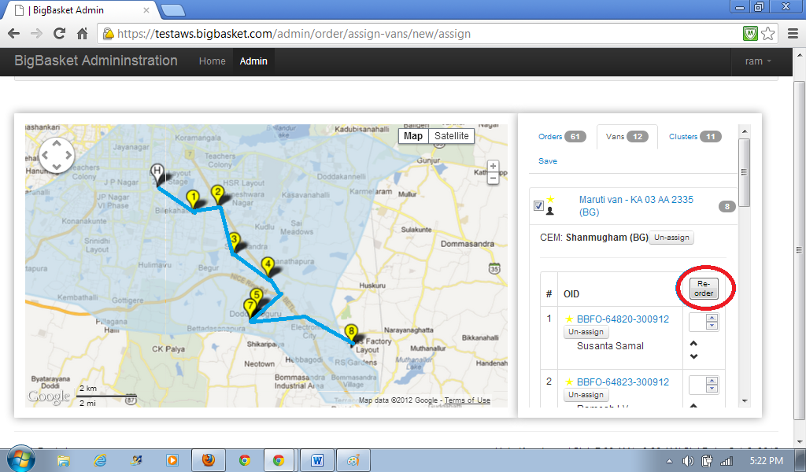

Once all orders are assigned, save route planning and compute ETA.

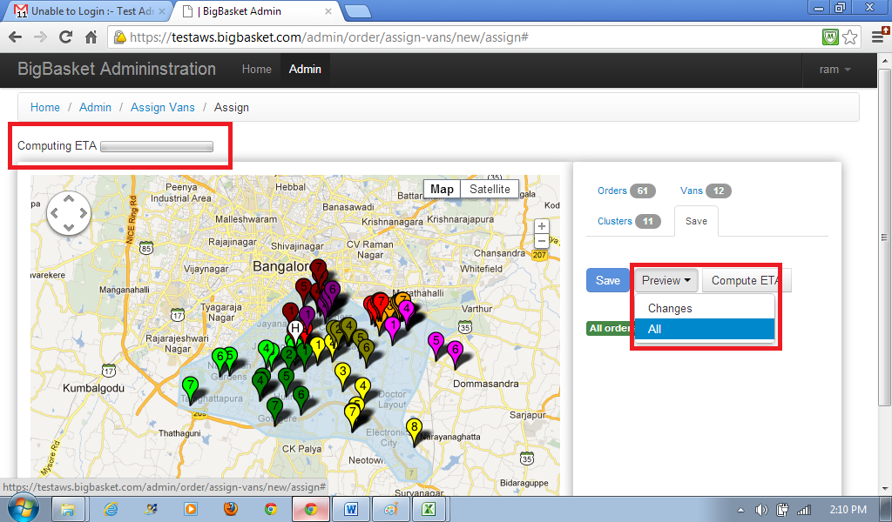

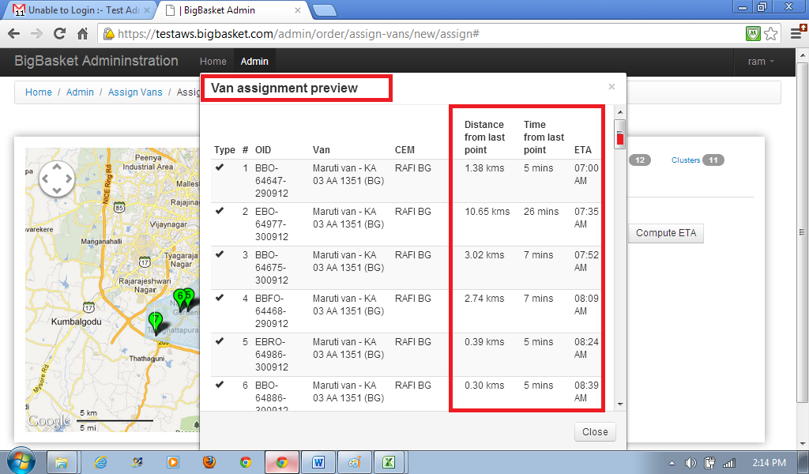

**B. Route Planning for Slot-2**

Since the orders are delivered back to back for two slots, once the route plan is completed for S1 in a sequence such that closest order to the hub is the first in the sequence and the farthest from the hub is the last order in the sequence, the last order in S1 will be the starting point for the first order of S2. The order icon of the last order of S1 will be shown in S2 on the map with an asterix , with details of Van # , the number of orders and crates it had delivered in S1. So, the first order of S2 should start from the asterix order icon shown for the previous slot. The first order in the sequence of S2 will be the closest to the asterix icon and the last order of S2 should be the one nearest to the Hub. Orders should be assigned depending upon the number of crates already assigned in Slot 1 and how many should be assigned for Slot 2.

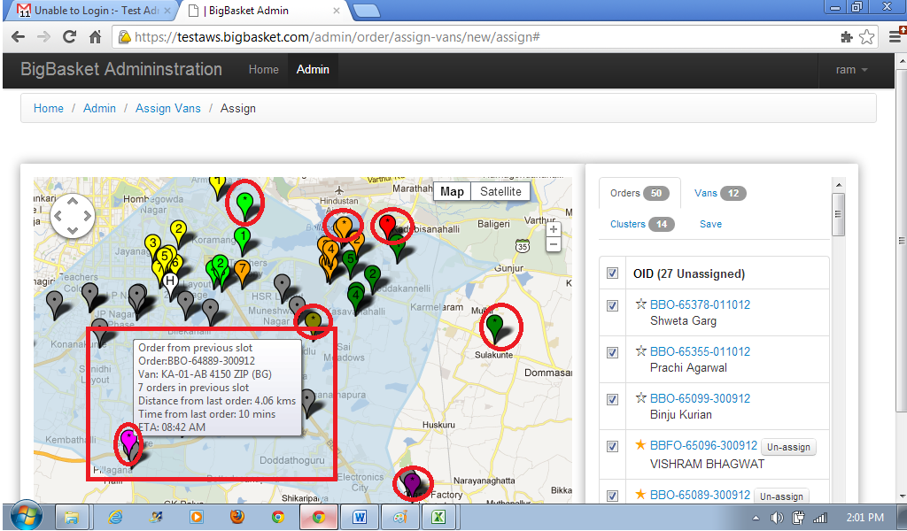

Same process repeated.

**5. Van wise invoice printing**

Option for printing invoices van wise;

Print wan wise invoice>DC Name>Date>Slot (drop down option S1&S2 or S3&S4).

**6. Print Delivery Sheet van wise/Bulk**

Delivery note is a statement carried by each CDSs consisting of the list of orders that to be delivered and amount to be collected by them in a sequence for that slot.

Option for printing the delivery Sheet – Aligned format of fit to page.

**Delivery Sheet Format**

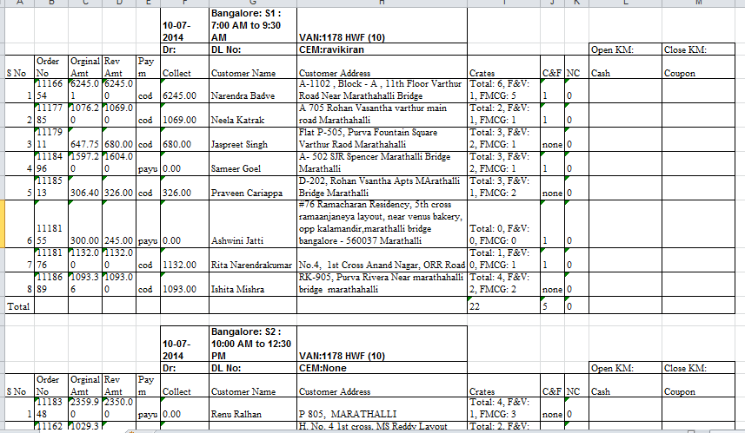

**7. Van wise collection settlement and raise exception report.**

* Verifying collections.
* Verifying vehicle related incidents.
* Verifying undelivered orders.
* Verifying customer returns of the products.
* Generating the exception report.
* Recording of collections.
* Performing reconciliation.
* Recording returns and allocating slot changes.
* Raising an exception report.

Option required;

Van wise settlement and record exception

**Date>DC Name>Slot1&S2/Slot3&S4/Van Name (Drop Down)**

List of all orders with delivery status based OMS update.

1. **Delivered Orders** - (Updated based on OMS update by CDE) option to update the cash collection. Card payments updated default based OMS sync.

**Returned items should be displayed** – AM should click on the product and say received ‘yes’. Invoice amount will be reduced and enter the exact amount.

This stocks will be added DC stocks and **Return to vendor process to be added.**

1. **Undelivered Orders** – Exceptions should be recorded against each order.
2. Delayed Orders– Drop Down Reasons and text box to update the explanation.
   * Late Dispatch from DC DC ( Text box to update the details by Area Manager)
   * Traffic ( Text box to update the details by Area Manager)
   * Traffic Police Caught
   * Customer was not available
   * Could not find the customer location
   * Complicated delivery location
   * Due to previous order
   * Reached on time but customer took time to take delivery
3. Cancelled Orders
   * Due late delivery
   * Customer is out of station
   * Customer ordered by mistake
   * Quality Issue
   * Brought already from out side
   * No cash
   * Cancelled by customer service
   * Merchant order
4. Slot change Orders

* Late delivery
* Customer not available at home
* Late Night
* No cash
* Could not find the customer address
* Customer service was not reachable

Once all the orders exception is recorded and saved, the exception report should be auto sent to concerned mails with detailed report.

1. **Delivery exception report (Email Alert once the settlement is submitted) with detailed report.**



**Summery sheet in the email attached excel;**

